**Bodie Fieldwork Summer 2020 – Comprehensive Log from 06/20 and 08/20**

**Map showing all drone flights for June 2020 (Jaffke)**

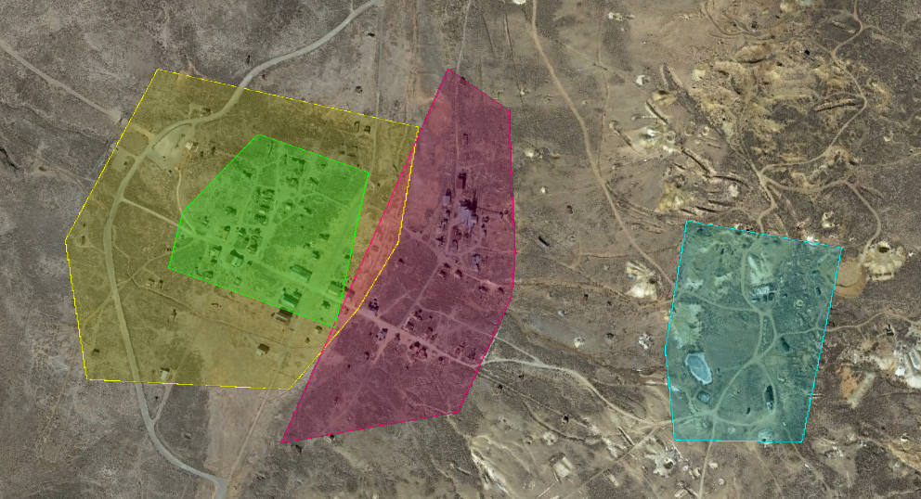

**Mission 4; 6/19/2020**

**Mission 3; 6/18/2020**

**Mission 2; 6/18/2020**

**Mission 1; 6/18/2020**

**Mission 1: Bodie Town – Pictures in Folder “103MEDIA”**

Date: 6/18/20

Time: 0608-0709

Area: 53 Acres

Images (planned): 826

Settings: "Enhanced 3D" @ "low light"

Resolution: 150 Ft

Camera: Phantom 4 Pro @ 65 degrees

Flight Direction: East/West

Notes: Sun creating long shadows and moving cows in town

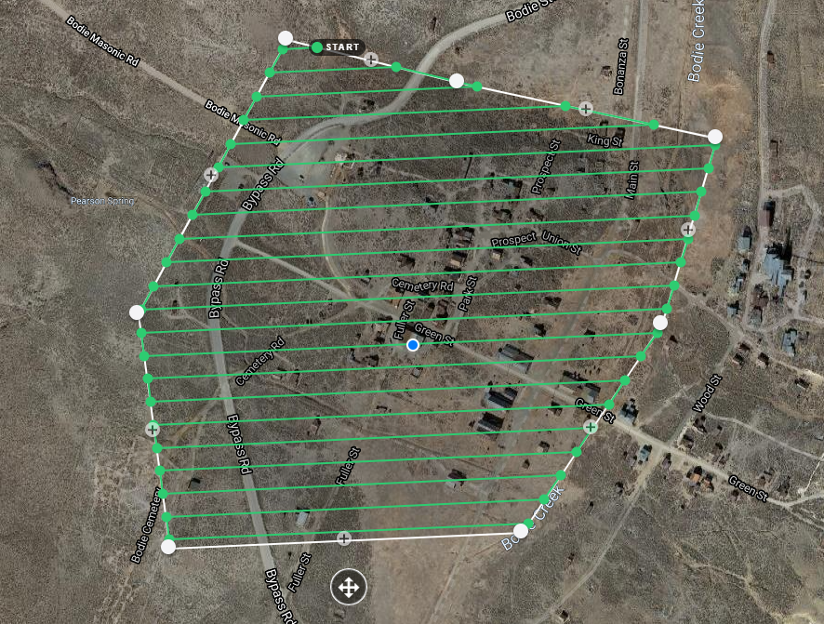

**Mission 2: Railroad Office/Roseklips – Pictures in Folder “100MEDIA”**

Date: 6/18/20

Time: 1222 - 1329

Area: 20 Acres

Images: planned = 856; actual = 1112

Settings “Enhanced 3D”

Resolution: 140 Ft

Camera: Phantom 4 Pro @ 65 degrees

Photo Numbers: 100MEDIA-DJI_0001-DJI_0999 + 101MEDIA-DJI-0001-0113

Flight Direction: North/South; East/West

Notes: Drone deploy acting strange after hot swaps

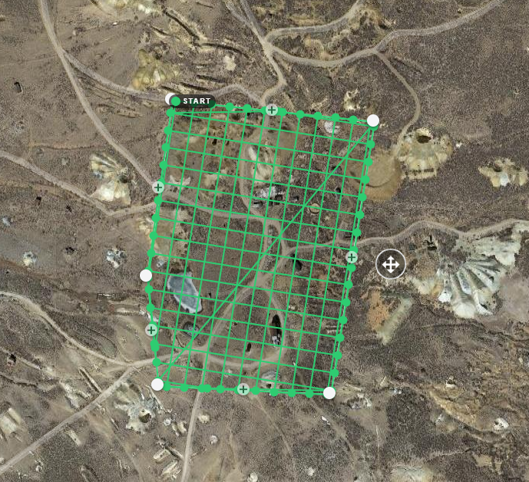

**Mission 3: Bodie Suburbs – Pictures in Folder “101MEDIA”**

Date: 6/18/20

Time: 1933-2017

Area: 29 Acres

Images: planned = 537; actual = 691

Settings : "Enhanced 3D" @ "low light"

Resolution: 140 Ft

Camera: Phantom 4 Pro @ 90 degrees

Photo Numbers: 101MEDIA-DJI_0114 - DJI_0804

Flight Direction: Northweast/Southwest

Notes: Drone deploy acting strange after hot swaps

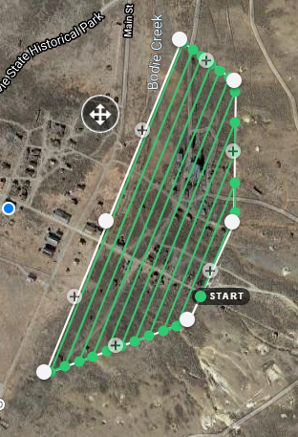

**Mission 4: Bodie Town (Take 2) – Pictures in Folder “102MEDIA”**

Date: 6/19/20

Time: 0527-0631

Area: 16 Acres

Images (planned): Planned = 767; Actual = 1086

Settings: "Enhanced 3D" @ "low light"

Resolution: 130 Ft

Camera: Phantom 4 Pro @ 65 degrees

Photo Numbers: 101MEDIA-DJI_0805 – DJI_0999 + 102MEDIA-DJI_0001 – DJI_0891

Flight Direction: Northwest/Southeast; Northeast/Southwest

Notes: Perfect lighting for almost the duration; had to reset mission after 2nd hot swap

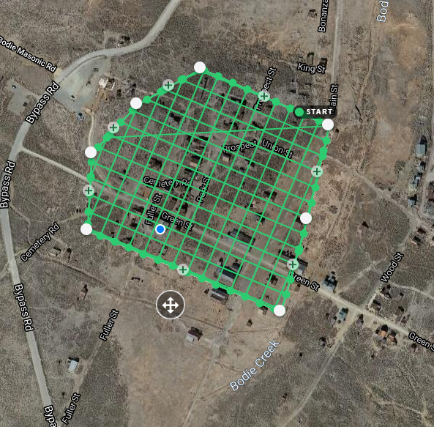

**Mission 5: Bodie Chinatown/Red Light District**

Date: 8/13/20 and 8/15/20

Time: 0730-0800 and 0630-0745

Area: 23 Acres

Images: 422 RGB and 422 Infrared

Settings: 60 side overlap; 60 front overlap

Resolution: 150 Ft

Camera: Mavic Enterprise Dual

Flight Direction: North/South

Notes: Began mission on Thursday morning during National Geographic filming but finished Sunday morning.

