Amec Foster Wheeler Energy & Partners Engineering Company

P.O. Box 30920

King Faisal Road

Al-Khobar 31952

Kingdom of Saudi Arabia

T +966 (0)13 668 5555

NEOM Regional Baseline & Monitoring Program

**Air Quality & Weather Monitoring Standards**

Amec Foster Wheeler Energy and Partners Engineering Company – February 2021

Report for

NEOM

Main contributors

Aimee Docwra

Dhiren Naidoo

Piercarlo Smith

Issued by

.................................................................................

Approved by

.................................................................................

Tarek Hamade PhD, MBA, PEng

Wood

Amec Foster Wheeler Energy & Partners Engineering Company

P.O. Box 30920

King Faisal Road

Al-Khobar 31952

Kingdom of Saudi Arabia

T +966 (0)13 668 5555

Doc Ref. 40754-WOD-XX-XX-RP-OA_S3_P01

Draft report disclaimer

This report has been prepared in a working draft form and has not been finalised or formally reviewed. As such it should be taken as an indication only of the material and conclusions that will form the final report. Any calculations or findings presented here may be changed or altered and should not be taken to reflect Wood’s opinions or conclusions.

Copyright and non-disclosure notice

The contents and layout of this report are subject to copyright owned by Wood (© Wood Environment & Infrastructure Solutions UK Limited 2019) save to the extent that copyright has been legally assigned by us to another party or is used by Wood under licence. To the extent that we own the copyright in this report, it may not be copied or used without our prior written agreement for any purpose other than the purpose indicated in this report. The methodology (if any) contained in this report is provided to you in confidence and must not be disclosed or copied to third parties without the prior written agreement of Wood. Disclosure of that information may constitute an actionable breach of confidence or may otherwise prejudice our commercial interests. Any third party who obtains access to this report by any means will, in any event, be subject to the Third Party Disclaimer set out below.

Third party disclaimer

Any disclosure of this report to a third party is subject to this disclaimer. The report was prepared by Wood at the instruction of, and for use by, our client named on the front of the report. It does not in any way constitute advice to any third party who is able to access it by any means. Wood excludes to the fullest extent lawfully permitted all liability whatsoever for any loss or damage howsoever arising from reliance on the contents of this report. We do not however exclude our liability (if any) for personal injury or death resulting from our negligence, for fraud or any other matter in relation to which we cannot legally exclude liability.

Management systems

This document has been produced by Wood Environment & Infrastructure Solutions UK Limited in full compliance with our management systems, which have been certified to ISO 9001, ISO 14001 and OHSAS 18001 by LRQA.

Document revisions

|  |  |  |
| --- | --- | --- |
| No. | Details | Date |
| 1 | Draft Report | 5th February 2021 |
|  |  |  |

Contents

1. Introduction 6

1.1 Preamble 6

1.2 Project Background 6

2. Reference Standards 7

2.1 Best practice and guidelines 7

2.2 Monitoring Objective 8

2.3 Air Quality Standards 8

2.4 Weather and Climate 10

2.5 Data Capture 10

3. Monitoring Equipment 11

3.1 Long-Term Air Quality Monitoring 11

3.2 Short-Term Air Quality Monitoring 11

3.3 Weather Stations 12

3.4 Equipment Summary 13

4. Survey and Monitoring Methods 14

4.1 Installation of Monitoring Equipment 14

AQMS 14

Aeroqual 500 14

Weather Stations 14

4.2 Long-Term Air Quality Monitoring Methodology 15

4.3 Short-Term Air Quality Monitoring Methodology 15

4.4 Quality Assurance/Quality Control 16

5. Baseline reporting 18

5.1 Meteorology 18

Analysis of wind speed and wind direction 18

Analysis of temperature, humidity, atmospheric pressure and precipitation 19

5.2 Air quality 20

Table 2.1 NEOM Ambient Air Quality Standards 9

Table 5.1 Example table for the analysis of temperature, humidity, atmospheric pressure and precipitation 19

Table 5.2 Example of how monitoring results will be reported 20

Figure 5.1 Example of a wind rose found at a monitoring station. 18

Figure 5.2 Example of a bar chart of the temperature recorded at two AQMS’s. 19

Figure 5.3 Example of polar plot of average concentration of pollutants for all wind directions/speeds. 21

# Introduction

## Preamble

Amec Foster Wheeler Energy and Partners Engineering Company (hereafter referred to as “Wood”) is pleased to provide this technical methodology to NEOM. This technical methodology outlines the proposed approach to the conduct of air quality monitoring programs within the NEOM development area, the scope of works to be performed including detailed information of the equipment to be used, references to international standards and best practices in the air quality sectors, a description of the equipment and deliverables.

## Project Background

Located in the northwest of Saudi Arabia on the Red Sea and Gulf of Aqaba coasts, NEOM spreads over an area of 26,500 km2 and encloses areas with a wide variety of activities and receptors. Very little information is currently available to characterize air quality condition in the region making necessary to collect primary data to support permit application for future developments.

As part of the NEOM Regional Baseline & Monitoring Program, NEOM required the development of a standard approach to the performance of air quality and weather monitoring campaigns ensuring that surveys for different NEOM developments will be undertaken in a consistent manner and to a level that meets or exceeds international best practice.

This document has been developed to describe in detail how the air quality survey should be executed, including:

* **Reference Standards** to ensure the proposed approach is robust and based on internationally accepted guidance.
* **Monitoring Equipment** description (AQMS, portable monitors and weather stations), including details of installation procedures, use and maintenance.
* **Survey and Monitoring Methods** to provide a detail description of method to be adopted to deliver this task
* **Baseline Reporting** structure describing how data collected through the survey will be processed and presented to form the baseline for future EIAs.

# Reference Standards

This section details the proposed approach and defines the reference standards on which the proposed methodology is to be based.

## Best practice and guidelines

The methodology for the ambient air quality monitoring program has been developed in accordance with guidance prescribed in the International Finance Corporation/World Bank (IFC/WB) Environmental Health and Safety General Guidelines, 2007[1].

The survey protocols and methodologies detailed within this document are tried and tested ways to evaluate air quality levels to satisfy the stringent requirements for Environmental and Social Impact Assessment (ESIA) air quality assessment in compliance with IFC standards.

The IFC/WB 2007 guidance states that, before a project is developed, baseline air quality monitoring at and in the vicinity of the site should be undertaken to assess background levels of key pollutants, in order to differentiate between existing ambient conditions and future project-related impacts.

Since NEOM covers a vast area and the location of future development might be subject to modifications, the proposed approach considers both long-term monitoring using an AQMS and spot measurements performed with portable monitors.

In line with IFC/WB prescriptions, the monitoring program will be based on the following principles:

* Monitoring parameters selected should reflect the pollutants of concern associated with future projects. The proposed approach considers a wide range of pollutants in order to cover emissions from a wide variety of existing and future developments.
* Monitoring locations should consider the project location in relation to existing and future receptors. The proposed approach will allow to be repeated at multiple locations based on the future expansion plans within NEOM.
* Sampling and analysis methods should apply national or international methods for sample collection and analysis. The ambient air quality monitoring equipment that will be used for the NEOM baseline study are compliant with guidance set out in the United States Environmental Protection Agency (US EPA) 40 CFR Part 53. The US EPA reference methods for monitoring is internationally accepted for monitoring equipment. Detailed information on the sampling methods is provided in **Section 3**.
* Sampling and analysis methods, including quality assurance and quality check (QA/QC) should be conducted by, or under, the supervision of trained individuals. The proposed approach considers that sampling should be undertaken by trained professionals and overseen by an experienced, senior air quality specialist.

## Monitoring Objective

The most important consideration in designing or implementing any monitoring system is defining its overall objectives. The scope of the air quality baseline study will be to improve the current understanding of the air quality conditions in the NEOM region and provide a spatial representation of pollutant levels within the region, including the identification of existing hot spots of poor air quality.

As a minimum the study should provide sufficient information to characterize the quality of airsheds where future developments will be located. According the IFC/WB 2007 guidance, an airshed should be considered as having poor air quality if nationally legislated air quality standards or WHO Air Quality Guidelines[2] are exceeded.

The primary purpose of the monitoring strategy is to ensure comparability of data across the NEOM area that will be used to achieve the following objectives:

* Measure representative pollutant concentrations across the NEOM project area. However, this will be dependent on the population/industrial density of an area, or lack thereof, when monitoring;
* Develop monitoring criteria for spot measurements i.e. determining suitable monitoring times and frequencies in areas that are populated versus areas that are sparsely populated.
* Measure background concentrations in areas where no activity takes place to ascertain the true baseline for the region;
* Support the development of appropriate management strategies in the NEOM area;
* For future purposes this will assist in tracking and reporting on air quality trends and the effectiveness of management strategies; and
* Ensure measurements are reliable and inter-comparative across the NEOM area.

## Air Quality Standards

Due to the potential variety of future developments within NEOM, it is considered necessary that the monitoring strategy covers a broad range of pollutants. The proposed list of pollutants that will be monitored includes:

* Benzene, Toluene, Ethylbenzene, Xylene (BTEX)
* Carbon Monoxide (CO);
* Inhalable Particulate Matter (PM10 and PM2.5);
* Nitrogen Oxides (NOX) as Nitrogen Dioxide (NO2);
* Ozone (O3);
* Hydrogen Sulfide (H2S);
* Non-methane hydrocarbons (NMHC); and
* Sulfur Dioxide (SO2).

Measured concentrations will be reported as "period means" (e.g. the average over the monitoring period) for comparison against the annual General Authority of Meteorology and Environmental Protection (GAMEP) and WHO standards and as maximum 1-hour, 8-hour, 24-hour (depending on the pollutant) for comparison against the short-term standards.

Table 2.1 below reports the applicable air quality standards for the NEOM baseline study. It is proposed that when both a GAMEP and a WHO standard is available for a given parameter, the most stringent standard is adopted to assess monitored concentrations.

The WHO provided Interim targets in recognition of the need for a staged approach to achieving the recommended guidelines for developing countries.

Table 2.1 NEOM Ambient Air Quality Standards

| Pollutant | Averaging Time | GAMEP  (µg/m3) | WHO  (µg/m3) |
| --- | --- | --- | --- |
| Nitrogen Oxides (NO2) | Hourly | 660(1) | 200 |
| Annual | 100 | 40 |
| Sulfur Dioxide (SO2) | Hourly | 730(1) | - |
| 24 Hours | 365(2) | 125 (Interim target-1)  50 (Interim target-2)  20 (guideline) |
| Annual | 80 | - |
| Carbon Monoxide (CO) | Hourly | 40,000(1) | - |
| 8 Hours | 10,000(1) | 10,000 |
| Ozone (O3) | Hourly | 295 | - |
| 8 Hours | - | 160 (Interim target-1)  100 (guideline) |
| Benzene (C6H6) | Hourly | 30(4) | - |
| Annual | 3(4) | 5 |
| Hydrogen Sulfide (H2S) | Hourly | 200 (5) | - |
| 24 Hours | 40 (6) | - |
| Particulate Matter (PM10) | 24 Hours | 340 | 150 (Interim target-1)  100 (Interim target-2)  75 (Interim target-3)  50 (guideline) |
| Annual | 80 | 70 (Interim target-1)  50 (Interim target-2)  30 (Interim target-3)  20 (guideline) |
| Particulate Matter (PM2.5) | 24 Hours | 35 | 75 (Interim target-1)  50 (Interim target-2)  37.5 (Interim target-3)  25 (guideline) |
| Annual | 15 | 35 (Interim target-1)  25 (Interim target-2)  15 (Interim target-3)  10 (guideline) |

[1] Not to be exceeded more than twice per thirty days.

[2] Maximum concentration not to be exceeded more than once per year.

[3] Maximum daily 8 hours.

[4] Alberta Ambient Air Quality Objectives and Guidelines Issued in August 2012.

[5] Not to exceed in any 12 months period

[6] Not to exceed more than once in any 12 months period

[7] Exceeding the PM10 and PM2.5 24 hours or annual standards because of abnormal natural background concentrations shall not be considered a violation of the designated standard.

## Weather and Climate

In addition to monitoring the physical pollutants, a meteorological sensor equipped with rain gauge should be mounted on 10 meter attached crank-up tower connected to the AQMS meteorological monitoring will be also conducted.

Three onshore portable weather stations are being deployed across the NEOM region as part of an initial baseline assessment. All weather stations will meet WMO Class 1 requirements and details are provided in **Section 3.3**.

## Data Capture

The standard approach regarding the required Data Capture Rate (DCR%) is set by the US EPA and states that the minimum DCR% for regulatory purposes is 75%. For the purpose of the NEOM standards for baseline monitoring the minimum requirements for DCR% is set at 80% for all recorded pollutants.

# Monitoring Equipment

To meet the objectives of the air quality monitoring study, two types of monitors i.e., Air Quality Monitoring Station (AQMS) and Aeroqual 500 Portable Monitors will be used to establish the baseline air quality conditions in the NEOM area.

## Long-Term Air Quality Monitoring

Monitoring will be performed continuously by one AQMS using standard reference methods as described in, and designated by, Title 40 of the United States’ Code of Federal Regulations, Chapter I, Subchapter C, Part 53 (40 CFR 53). The following reference method will be followed:

* PM10 is monitored in accordance with 40 CFR 53 automated equivalent method EQPM-0404-151 using dual beta attenuation monitoring;
* PM2.5 is monitored in accordance with 40 CFR 53 automated equivalent method EQPM-1013-211 using dual beta attenuation monitoring;
* NOX (as NO2) is monitored in accordance with 40 CFR 53 automated reference method RFNA-0118-249 using chemiluminescence;
* O3 is monitored in accordance with 40 CFR 53 automated equivalent method EQOA-0515-225 UV photometry;
* SO2 is monitored in accordance with 40 CFR 53 automated equivalent method EQSA-0802-149 using pulsed UV fluorescence;
* H2S is monitored by pulsed ultraviolet (UV) fluorescence based on ultraviolet fluorescence principle;
* BTEX is monitored using gas chromatography with a photo-ionization detection system in accordance with the principal requirements of the European Committee for Standardization (CEN) standard 14662 Part 3;
* CO is monitored in accordance with 40 CFR 53 automated reference method RFCA-0915-228 based on carbon monoxide detection by absorption of infrared light; and
* Meteorological parameters are monitored in accordance with US EPA Guidance Document ‘Quality Assurance Handbook for Air Pollution Measurement Systems Volume IV: Meteorological Measurements Version 2.0 (Final)’.
* Daylight Meter: LXT-TRM is a fixed-mount light meter consisting of a transmitter unit and an external light sensor probe with a 1.5 m / 4.92' long cable and wall-mounting bracket

## Short-Term Air Quality Monitoring

Where additional spot measurements is required this will be undertaken with Aeroqual 500 portable monitors (or equivalent) using US EPA equivalent methods for determining pollutant concentrations at multiple locations across a large area. This equipment should use Gas Sensitive Semiconductor (GSS) and Gas Sensitive Electrochemical (GSE) sensors which provide good correlation with reference methods[3].

The list of sensors that will be mounted on the monitor is provided below:

* NO2 Filtered gas sensitive semiconductor sensor, 0-1 ppm range
* SO2 Fan-sampling gas sensitive electrochemical sensor: 0-10 ppm range
* CO Fan-sampling gas sensitive electrochemical sensor: 0-25 ppm range
* O3 Fan-sampling gas sensitive semiconductor sensor: 0-10 ppm range
* NMHC Fan-sampling gas sensitive semiconductor sensor: 0-25 ppm range
* PM2.5 and PM10 sensor head with RH correction

## Weather Stations

One meteorological sensor with rain gauge will be mounted on 10 meter attached crank-up tower connected to the AQMS and will measure:

* Temperature
* Wind speed
* Wind direction
* Solar Radiation
* Relative Humidity
* Rainfall

Three Rainwise PORTLOG Portable Weather Station, solar-powered, are being installed as part of the initial baseline. Any weather stations deployed at NEOM must meet WMO Class 1 requirements and the following parameters will be recorded:

* Barometric Pressure (200 to 1100 mbar)
* Wind speed and direction - measurement height at 10 meters, with a resolution of 0.01m/s for wind speed and 10° for wind direction
* Air temperature (wet and dry bulb) to be measured at 1.25 - 2 m above ground
* Relative humidity with resolution at 1%
* Solar, UV and net radiation (0 to 2,000 w/m2)
* Relative humidity
* Rainfall
* Triple-BSNE Sand Catcher

## Equipment Summary

The equipment list currently deployed, with applicable analytical methods, is provided in Table 3.1. Any future equipment should be to equivalent standard

Table .: Equipment specifications

| Equipment Type | Air Quality Monitoring Station | Air Quality Portable Monitors | Meteorological Stations |
| --- | --- | --- | --- |
| Parameters to monitor | NOx – Chemiluminescence  SO2 – Fluorescence  H2S – Fluorescence  CO – Gas filter correlation  O3 – UV Photometric  BTEX – airToxic  PM10/PM2.5 – Dual beta continuous particulate monitor  Meteorological station - 10 Meter attached Crank-up Tower, Temp., Wind speed, wind direction, Solar Radiation, Relative Humidity, Rain Gauge. | Aeroqaul 500 with lithium batteries and power packs. Data logging device and software included.  The Aeroqual 500 will monitor SO2, CO, O3. NMHC. NO2, PM10/PM2.5, temperature, and humidity.  The Aeroqual 500 has interchangeable sensors to monitor a range of parameters. | Rainwise PORTLOG Weather Station (solar-powered) mounted on 10 feet tripod  Barometric pressure  Temperature  Wind speed  Wind direction  Solar Radiation  Relative Humidity  Rainfall  Triple-BSNE Sand Catcher |
| Quantity | 1 | 2 | 3 |
| Location | Multiple locations | Multiple locations | Multiple locations |
| Duration per location | To be defined based on the number of locations | See Section 4.3. | 12 Months at all 3 locations |

# Survey and Monitoring Methods

## Installation of Monitoring Equipment

### AQMS

AQMS equipment will be installed in a mobile analyzer shelter mounted on a truck and will monitor continuously for the duration of the project. The AQSM will be installed by the sub-contractor and the following should be noted with regards to the installation:

* Where mains power is not available at a site diesel generators will be used to provide power to the AQMS. The generator will be a 50 kVA generator with a sound attenuated enclosure. If feasible (depending on security and safety conditions) the generator will be installed as far as possible downwind of the AQMS (ideally 50 meters), to avoid any interference with the pollutant readings at the monitor.
* A concrete base will be constructed to ensure that the AQMS is on a level platform prior to the commencement of the monitoring.
* All analyzers for the AQMS will be housed in a shelter with dimensions of 5.5m x 2.6m x 2.2m. A ladder will be included for roof access with a guard rail. Within the shelter lighting, air conditioning and a UPS will be installed.
* To commission the monitor, the following will be undertaken:
* Site preparation.
* All engineering, plumbing, installation, and system integration of the analyzers and met sensors within the shelter.
* Commissioning and start-up of the AQMS.
* Site acceptance test by sub-contractor including all required calibration tests.
* On-site user training.
* Depending on the location and security of the area, installation of a fence around the monitor for security purposes may be required.

### Short term spot measurement (Aeroqual 500 or equivalent)

No physical installation is required for short term spot monitoring equipment. However, the sensor head is unique for a specific pollutant and will need to be changed to record the concentration of different pollutants. The monitors should be equipped with lithium batteries so will not require additional power sources.

### Weather Stations

The portable weather stations will be installed on a ten-feet tripod and include the installation of a fence for security purposes if deemed necessary. The weather stations should be equipped with a minimum 3-Watt solar panel and 5 Ah sealed lead acid battery to ensure reliable operation and do not require additional power sources.

## Long-Term Air Quality Monitoring Methodology

It is recognized that a knowledge of the baseline air quality statistics for a particular area is essential in beginning the active management of an airshed, including the protection of atmospheric quality and human health and also in providing a basis for the regulation of industries that discharge pollutants into the atmosphere.

The AQMS will collect data over a 12-month period at one or more locations that will be identified through a desktop study. The identification of the most appropriate locations to site the AQMS will be achieved taking into account the following matters:

* Locations of the main industrial sources of air pollutant emissions within NEOM;
* The prevailing meteorology (with a focus on wind direction);
* The location of sensitive existing and future receptors (residential, commercial and institutional buildings);
* Site topography and the potential shielding effect of large buildings and structures; and
* Practical issues such as safe access and cellular phone network access.

All recorded data will be stored securely on computer media, with appropriate back-ups and it will also be possible to download data directly from the stations using an automated transmittal process via 4G SIM card comms.

The data logger installed on the AQMS includes hardware and Enviro Data Das software license. The Data Logger will be able to communicate with Neom’s online system via a GPRS modem.

The monitoring program will include data acquisition, processing, validation and ratification procedures and reporting of monitoring results with appropriate data analysis in a final report (see **Section 5**).

## Short-Term Spot Monitoring Methodology

A desktop study should be undertaken to select locations for the short-term monitoring program. The study should be based on a review of the latest satellite imagery to identify existing sources and receptors, as well as a review of NEOM future development plans in order to take into account future projects. All proposed locations will be shared with NEOM for approval.

The exact position of each monitoring location will need to be determined by personnel in the field based on a review of security and safety conditions.

Since there are no criteria in terms of averaging periods for undertaking spot measurements, the following methodology (Table 4.1) is proposed, in correlation to the spatial scale of the area in which monitoring will be undertaken, to determine suitable averaging times and frequency for monitoring.

The field technicians will be trained on the use of the criteria. The decision on the spatial class will be undertaken in the field based on the criteria and the relevant averaging times for monitoring will be used.

Table .: Spatial representation criteria

| Spatial Class | Criteria | Monitoring Times per Pollutant | Frequency of monitoring |
| --- | --- | --- | --- |
| Class 1 | Areas with no activities taking place | 15 minutes or until results stabilize | Monthly |
| Class 2 | Areas with small scale industrial activities | 30 minutes or until results stabilize | Biweekly |
| Class 3 | Areas with medium/large scale activities | 60 minutes or until results stabilize | Weekly |

The equipment should be operated in areas with free circulation of air, ideally at human breathing height, generally at a height of between 1.5 and 2 m, but in all cases no higher than 5 m. The equipment should be placed to avoid the possibility of sampling stagnant air and should not be located on the corners of any buildings (to avoid the possibility of sampling an area of higher than usual turbulence).

Additional requirements include avoiding sampling in close proximity (less than 10 m) to the following:

* Heater flues (particularly low-level balanced flues);
* Trees and other vegetation;
* Air conditioning outlets;
* Extractor vents; and
* Underground ventilation shafts.

A handheld computer tablet and GPS will be used to document the areas covered by survey and locations where photographs were taken.

A specific field form should be implemented to help the data recording during the implementation of the survey. The form should be uploaded on an application loaded on the handled tablet. The survey results should be uploaded daily to the Neom Central data system (or as soon as connection to network is available) to be seen in an online platform which can be made available to the project team to monitor progress.

Hard copies of field forms shall be compiled for each survey area as backup in case of technical issues with tablets. If electronic data is lost due to an unplanned event, the hard copy should be submitted as soon as possible to the air quality task lead.

## Quality Assurance/Quality Control

Site visits, instrument calibrations and program audits are all important elements of an effective QA/QC system. Requirements are somewhat dependent on the sampling methods employed and resources available, but each element will be adhered to as part of the QA/QC procedure.

The calibration requirements and regular inspection for the monitors should meet the specifications set out by the suppliers to ensure the accuracy of the results. In addition, the equipment suppliers should undertake regular maintenance of the AQMS to ensure it is operating efficiently.

As a minimum the following QA/QC requirement, presented in Table 4.2 should be followed.

Table .: QA/QC Procedures

| QA/QC | AQMS | Portable Monitors |
| --- | --- | --- |
| Maintenance | Monthly, however dependent on the robustness of the monitor | After every sampling event standard check should be undertaken to determine if the filters are blocked. |
| Calibration | Automatic zero/span calibration will be undertaken daily.  Gas calibrations should be undertaken as recommended by the supplier | Calibration should be undertaken after every monitoring event.  Automatic zero/span calibrations will be undertaken prior to use. |
| Responsibility | Supplier and Field Technicians | Supplier and Field Technicians |

The AQMS and portable monitors will be subject to a QA/QC validation process prior to installation or use. The field team leader shall be responsible for ensuring that all requirements for air quality data management are met and is required to:

* Carry out routine operation and calibration procedures for the equipment at the site, in conformance with the equipment manual.
* Identify and report potential problems and changes to the site and surrounding area to the field supervisor.
* Undertake simple tests and repairs to the site and/or equipment as required.
* Take records of calibrations undertaken and submit them to NEOM.
* Use their experience of air pollution monitoring to identify and report any faults or potential faults as soon as possible.
* Provide information on local activities that may affect the pollution climate or site suitability at the monitoring station.

# Baseline reporting

Regular monthly progress reports will be issued to NEOM including analysis of each recorded parameter using OpenAir. OpenAir is tool for air quality analysis based on the ‘R’ coding language.

## Meteorology

The proposed stations will include a web application for real time view of data on that the station will upload on the cloud platform. This is a very important feature that will not only provide a user-friendly tool visualize data, but also allow to identify any malfunctions and quickly intervene to fix it minimizing missing data or the loss of valuable data.

The analysis of meteorological data should consider the following parameters which are recorded by the meteorological sensors: temperature, humidity, atmospheric pressure, precipitation, wind speed and wind direction.

### Analysis of wind speed and wind direction

The analysis of wind speed and wind direction should be carried out by producing wind rose figures for each meteorological station. The prevailing wind directions and wind speeds found at each station should be compared with each other, and conclusions should be drawn on the contributing factors for these results based on local activity and environment. An example of a wind rose is provided below as Figure 5.1.

An investigation into the agreement of results found at each monitoring station should be made. This can made by obtaining a wind rose for a separate monitoring station near by or within the vicinity of the two monitoring stations.

Figure . Example of a wind rose found at a monitoring station.

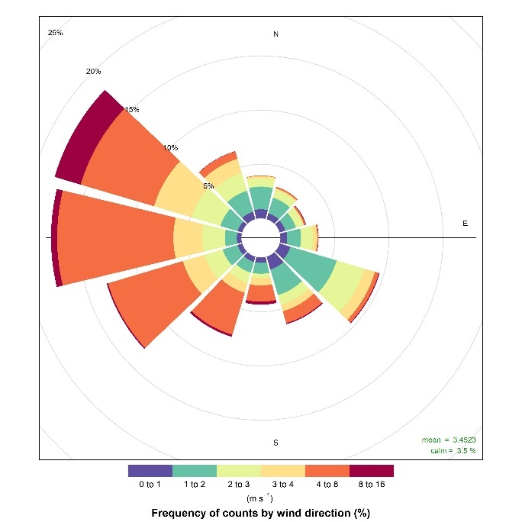

### Analysis of temperature, humidity, atmospheric pressure and precipitation

Recorded data for temperature, humidity, atmospheric pressure and precipitation should be recorded in a table such as Table 5.1reported below. Data for temperature, humidity, atmospheric pressure and precipitation should be collected for the entire monitoring period.

Table 5.1 Example table for the analysis of temperature, humidity, atmospheric pressure and precipitation

| Month | Temperature (°C) | | | Humidity (%) | | | Pressure (mbar) | | Precipitation (mm) |
| --- | --- | --- | --- | --- | --- | --- | --- | --- | --- |
| Min | Avg | Max | Min | Avg | Max | Min | Max |
| March |  |  |  |  |  |  |  |  |  |
| April |  |  |  |  |  |  |  |  |  |
| May |  |  |  |  |  |  |  |  |  |
| June |  |  |  |  |  |  |  |  |  |
| July |  |  |  |  |  |  |  |  |  |
| August |  |  |  |  |  |  |  |  |  |
| September |  |  |  |  |  |  |  |  |  |

For further analysis, bar charts should be made to present the findings from each weather station. An example of a bar chart reporting the temperatures reported at two monitoring stations is presented below as Figure 5.2.

Figure . Example of a bar chart of the temperature recorded at two AQMS’s.

## Air quality

The results section of the air quality monitoring report should describe whether or not any exceedances of the measured pollutants were reported during the monitoring period. The data capture for the monitoring period should also be reported. The limitations of the monitoring programme should be disclosed, alongside any limitations in the comparison of results between different locations.

Results from the AQMS will be reported in a report as a period mean for each pollutant monitored. The period mean will represent an average concentration of each pollutant measured for the entire reporting period. Whilst the monitoring is being undertaken, results will be collected from the AQMS each month and reported in a table.

The cumulative concentration will be reported as data is received each month. An example of the final results table is shown below as Table 5.2**.** Data collected will be compared against applicable GAMEP and WHO standards.

Table 5.2 Example of how monitoring results will be reported

| AQMS_01 | Averaging Time | Measured Concentration  (µg/m3) | GAMEP  Limit  (µg/m3) | WHO  Limit  (µg/m3) | % of GAMEP Limits (or Exceedance) | % of WHO Limits (or Exceedance) | Data Capture  % |
| --- | --- | --- | --- | --- | --- | --- | --- |
| Nitrogen Oxides (NO2) | Hourly |  | 660 | 200 |  |  |  |
| Annual |  | 100 | 40 |  |  |
| Sulfur Dioxide (SO2) | Hourly |  | 730 | - |  |  |  |
| 24 Hours |  | 365 | 125 |  |  |
| Annual |  | 80 | - |  |  |
| Carbon Monoxide (CO) | Hourly |  | 40,000 | - |  |  |  |
| 8 Hours |  | 10,000 | 10,000 |  |  |
| Ozone (O3) | Hourly |  | 295 | - |  |  |  |
| 8 Hours |  | - | 160 |  |  |
| Benzene (C6H6) | Hourly |  | 30 | - |  |  |  |
| Annual |  | 3 | 5 |  |  |
| Hydrogen Sulfide (H2S) | Hourly |  | 200 | - |  |  |  |
| 24 Hours |  | 40 | - |  |  |  |
| Particulate Matter (PM10) | 24 Hours |  | 340 | 50 |  |  |  |
| Annual |  | 80 | 10 |  |  |
| Particulate Matter (PM2.5) | 24 Hours |  | 35 | 25 |  |  |  |
| Annual |  | 15 | 10 |  |  |

In order to provide a comprehensive analysis of the behavior of each pollutant, the correlation between concentration, wind direction and wind speed should be represented using polar plots. Polar plots can be made by use of OpenAir.

The aim of the polar plot is to show the average concentration of each pollutant for all the wind directions/speeds combinations recorded for entire monitoring period. This allows to understand, for example, from which direction the highest concentrations of a certain pollutants are coming from, enabling to make assumptions regarding the source of such contributions.

An example of such a polar plot is provided below as Figure 5.3.

Figure . Example of polar plot of average concentration of pollutants for all wind directions/speeds.

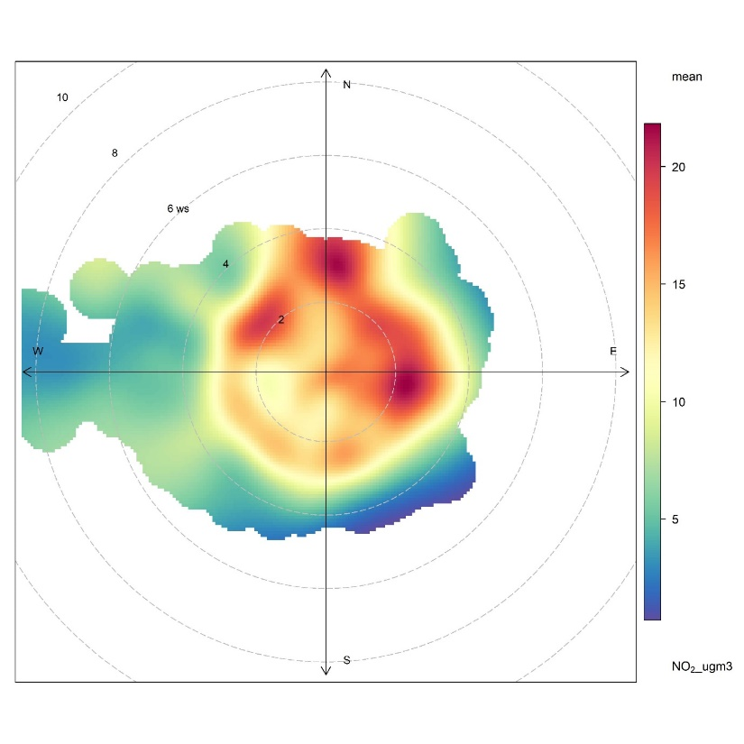



1. IFC/WB, Environmental Health and Safety (EHS) General Guidelines, 2007
2. World Health Organization (WHO). Air Quality Guidelines Global Update, 2005
3. South Coast AQMD. Air Quality Sensor Performance Evaluation Center. <http://www.aqmd.gov/aq-spec/evaluations/summary-gas>